**Cypress Installation**

|  |  |  |
| --- | --- | --- |
| **Date** | **Version** | **Created By** |
| **11-Mar-2024** | **1.0** | **Prince** |

**Steps to Setup Cypress:**

1. **Download and Install software (Pre-requisite: Elevated Privileges)**
   1. Download the latest LTS version of [Node.JS](https://nodejs.org/en/download)   
      Use Windows x64 installer  
      Request Elevated Privileges from [IIQ](https://iiq.nwie.net/identityiq/workitem/commonWorkItem.jsf" \l "/commonWorkItem/session) if needed
   2. Download the latest version of [Visual Studio Code](https://visualstudio.microsoft.com/downloads/) (VS Code).   
      Use Windows x64 installer
   3. Create a new folder for cypress project:  
      C:\Users\**<NWIE ID>**\Cypress\**<sample-project>**  
      **<NWIE ID>** and **<sample-project>** are variables that an associate or contractor needs to replace  
      **<sample-project>** can be named the same or renamed
   4. Open sample project folder in VS Code

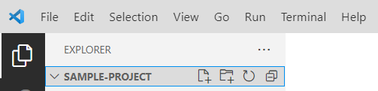

1. Create a new file named **.npmrc** in the sample project. Copy and paste text below in the file:  
   registry=https://art.nwie.net/artifactory/api/npm/npm/  
   proxy=http://127.0.0.1:9000  
   http-proxy= http://127.0.0.1:9000  
   https-proxy= http://127.0.0.1:9000  
   strict-ssl=true  
   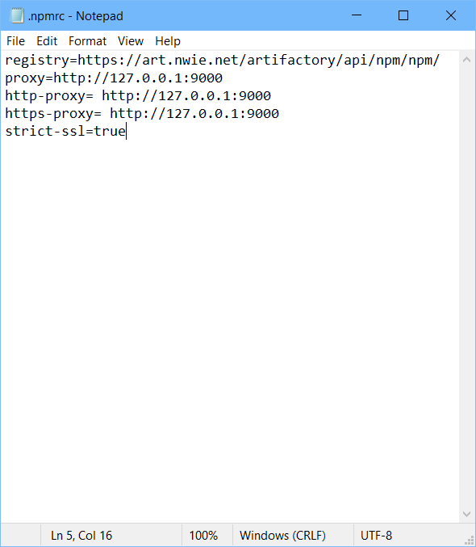

Add this file in Cypress automation framework folder.

Download the Cypress automation project from following location (Please find latest version of project)

[EDS INTERSTELLAR Team - Cypress - All Documents (sharepoint.com)](https://onyourside.sharepoint.com/sites/EDS/EDS-INTERSTELLAR/SharedDocuments/Forms/AllItems.aspx?RootFolder=%2Fsites%2FEDS%2FEDS%2DINTERSTELLAR%2FSharedDocuments%2FTesting%2FAutomation%2FCypress&OR=Teams%2DHL&CT=1714157665840&clickparams=eyJBcHBOYW1lIjoiVGVhbXMtRGVza3RvcCIsIkFwcFZlcnNpb24iOiI0OS8yNDAzMTQxNDcyMSIsIkhhc0ZlZGVyYXRlZFVzZXIiOmZhbHNlfQ%3D%3D) > NWIE CAutomation

example: C:\Users\GUPTS71\OneDrive - Nationwide\Documents\NWIE CAutomation\.npmrc

Open the folder in VS studio

1. **Environmental Variables setup** –
   1. Click the Windows menu and search for “**Edit Environment Variables**”

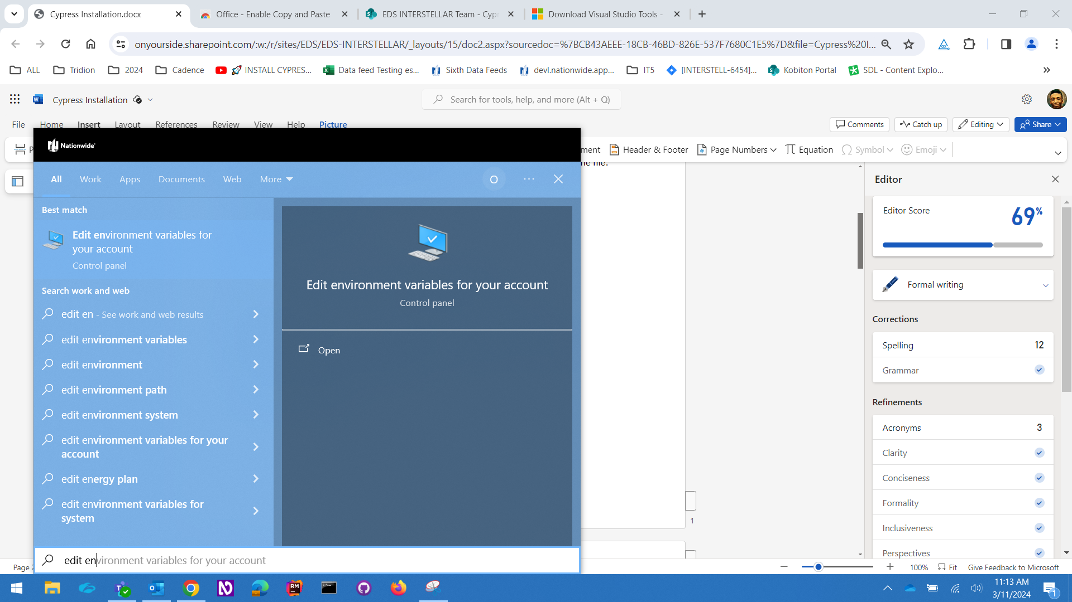

* 1. Add two new variables and values without any whitespace when pasting and Click OK:  
     **a) Name**: no_proxy  
     **Value**:127.0.0.1,localhost,.nwie.net,nwie.net,wapp000201.server.nwie.net,rrc.nwie.net,api-dev.nwie.net,newdcd-alpha.nwie.net,yarnpkg.com  
       
     b) **Name**: NODE_EXTRA_CA_CERTS  
     **Value**: C:\Users\<NWIE ID>\nw-ca-all.pem  
     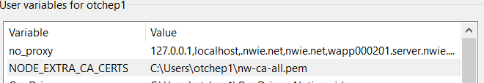
  2. Remove any conflicting environment variables like proxy, etc. and click OK

1. **Download** [certificate](https://onyourside.sharepoint.com/:u:/r/sites/EDS/EDS-INTERSTELLAR/SharedDocuments/Testing/Automation/Cypress/nw-ca-all.pem?csf=1&web=1&e=Gu4yO2) and move or paste it in the file path value above:  
   C:\Users\<NWIE ID>\<certificate>  
   **<NWIE ID>** is the **short name** that an associate or contractor needs to replace  
   **<certificate>** is **nw-ca-all.pem** from NODE_EXTRA_CA_CERT variable  
   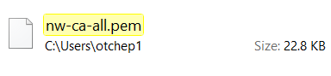
2. **Install Cypress** 
   1. **Open Visual Studio Code** terminal by clicking:  
      Terminal > New Terminal  
      Command Prompt (cmd) or Git Bash (bash) terminal can be used  
      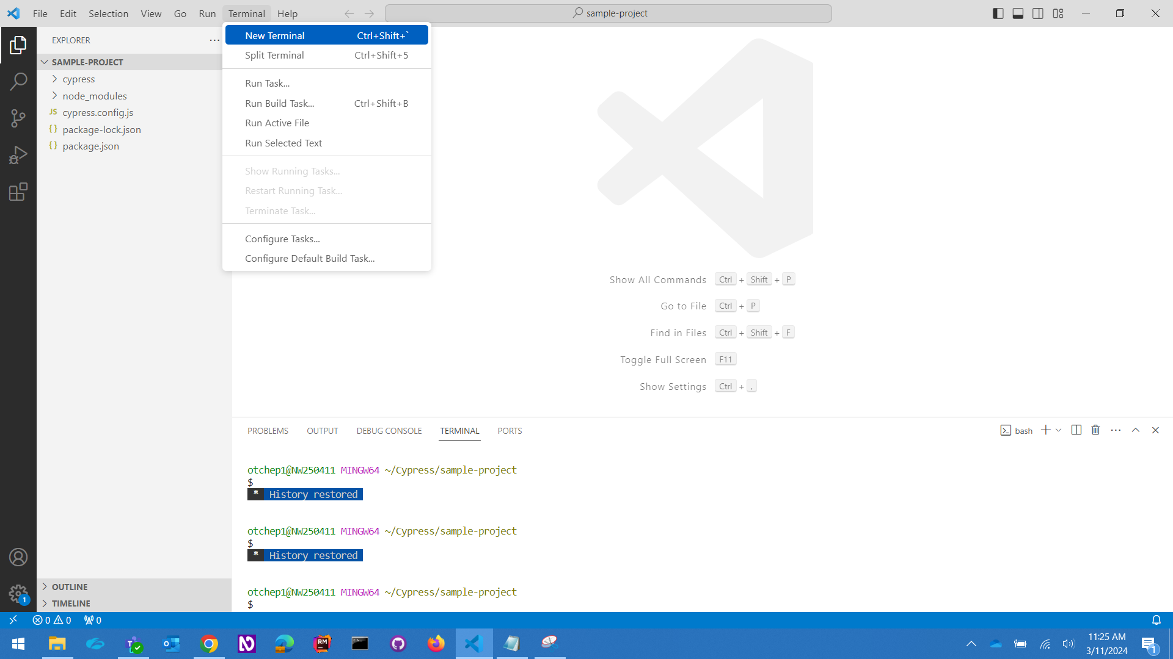

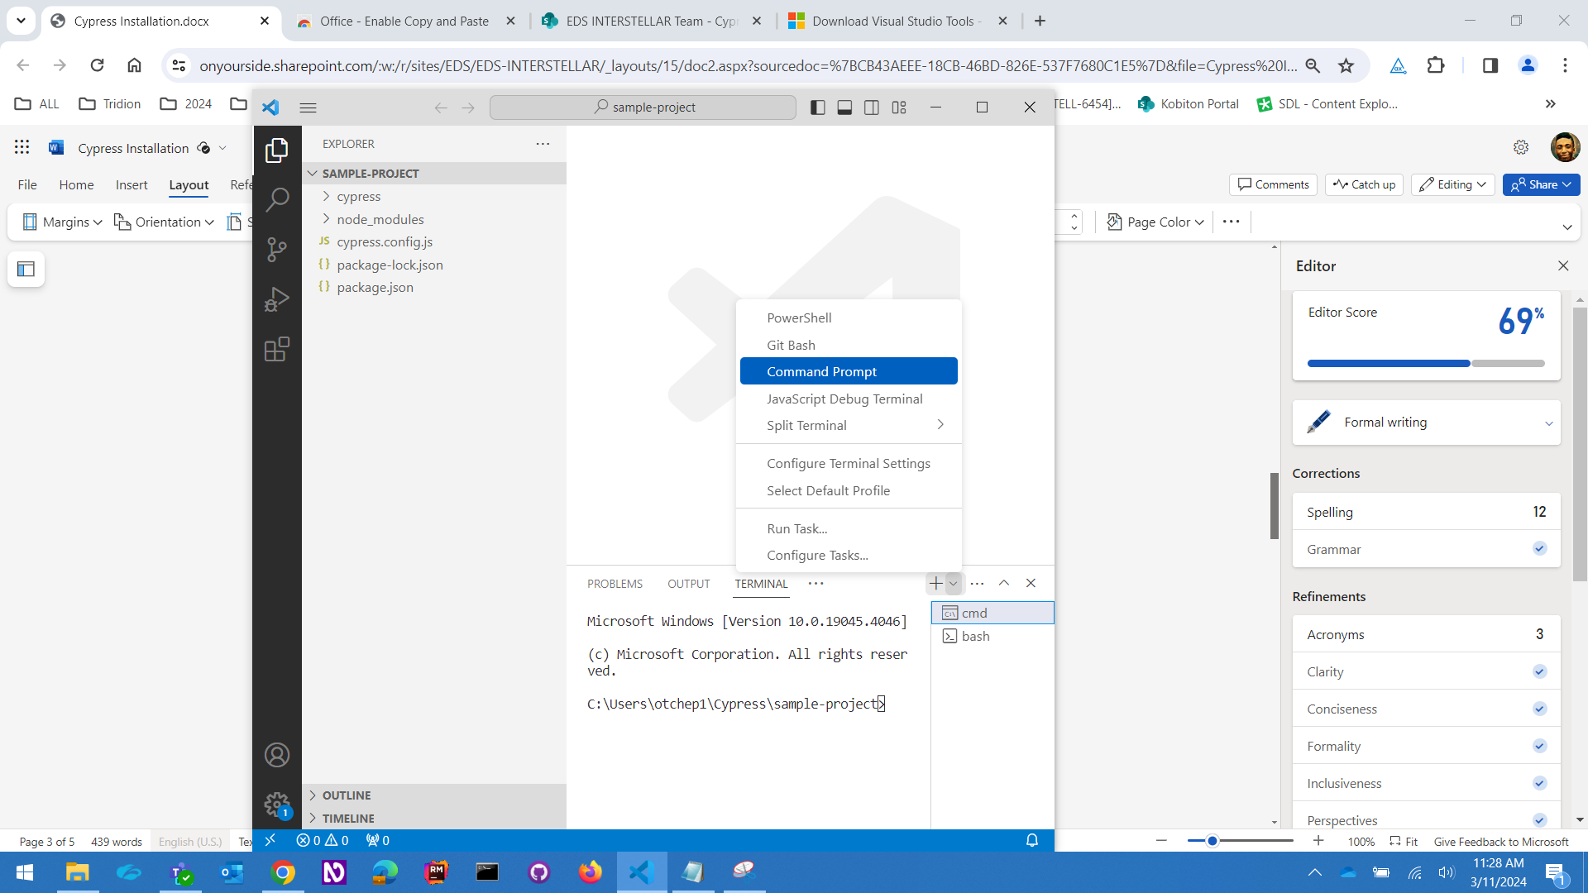

* 1. Run command in terminal: **Type the following command instead of copy paste.**  
     npm init -y

* 1. A package.json should appear in the project folder   
     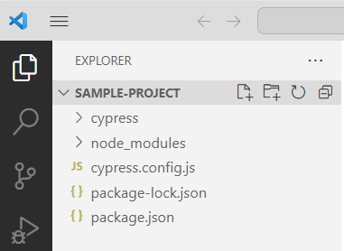
  2. Download [Cypress](https://download.cypress.io/app/)
  3. Extract file here:   
     C:\Users\**<NWIE ID>**\AppData\Local\Cypress\Cache  
     **<NWIE ID>** is the **short name** of an associate or contractor
  4. The file path should be:  
     C:\Users\**<NWIE ID>**\ AppData \Local\Cypress\Cache\12.17.4\Cypress

**<NWIE ID>** is the **short name** of an associate or contractor

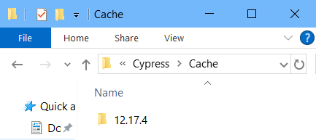

* 1. If Cypress version is not 12.17.4, run this command in VS Code terminal:  
     *npm install cypress@12.17.4*
  2. Run this command to verify installation:  
     *npx cypress –v*
  3. Run this command to verify if Cypress is installed successfully:  
     *npx cypress verify*

1. **Setup Artifactory configuration** 
   1. **Run this command on command line to set Artifactory configuration**:  
      *npm config set registry* https://art.nwie.net/artifactory/api/npm/npm/
   2. Run this command to verify the registry setting was saved:  
      *npm config list*
   3. Execute sample test in Cypress

Run this command to start Cypress:  
*npx cypress open*

1. **Setup framework –**   
   1. Download [NWIE CAutomation 02252024.zip](https://onyourside.sharepoint.com/:u:/r/sites/EDS/EDS-INTERSTELLAR/SharedDocuments/Testing/Automation/Cypress/NWIE%20CAutomation%2002252024.zip?csf=1&web=1&e=pfeKdP) to Cypress  
      It may take a long time to complete.
   2. Use “Ctrl + C” in VS Code terminal to stop Cypress

-------------------------------------------------------------------------------------------------------------------------------------

**Troubleshooting tips** -

1. Geeting error message when installing Cypress from visual studio terminal

npm ERR! The Cypress App could not be downloaded.  
 npm ERR!  
 npm ERR! Does your workplace require a proxy to be used to access the Internet? If so, you must configure the HTTP_PROXY environment variable before downloading Cypress. Read more: <https://on.cypress.io/proxy-configuration> npm ERR!  
 npm ERR! Otherwise, please check network connectivity and try again:  
 npm ERR!  
 npm ERR! ----------  
 npm ERR!  
 npm ERR! URL: <https://download.cypress.io/desktop/12.17.4?platform=win32&arch=x64> npm ERR! Error: unable to get local issuer certificate  
 npm ERR!

**Solution**:

1. Getting below error when trying to install Cypress

PS C:\Users\samals1\AppData\Local\Cypress> npm install [cypress@12.17.4](mailto:cypress@12.17.4) npm ERR! code UNABLE_TO_GET_ISSUER_CERT_LOCALLY  
 npm ERR! errno UNABLE_TO_GET_ISSUER_CERT_LOCALLY  
 npm ERR! request to <https://registry.npmjs.org/cypress> failed, reason: unable to get local issuer certificate

npm ERR! A complete log of this run can be found in: C:\Users\samals1\AppData\Local\npm-cache\_logs\2024-04-26T19_22_48_514Z-debug-0.log

**Solution**: